LIBER Ontology Preparation Manual

The LIBER Ontology Preparation tool enables you to adapt an ontology for use in LIBER, so that natural language descriptions can be generated from RDF-triples defined by this ontology, and so that these RDF-triples can be accessed, queried and created through the LIBER interface.
Your ontology must be finished when you start adapting it for LIBER. The only alterations the Preparation tool makes to LIBER is to add minimum cardinality constraints and comments; in all other respects the ontology will remain identical.

1. Getting started

You must have Java 6 and Ant installed to run the tool. First ensure that ‘JAVA_HOME’ and ‘PATH’ have been set to the Java 6 JDK. Open a command window, navigate to this directory, and type a command. You have the following options:

- ant clean: Remove build and documentation directories;
- ant compile: Compile all source files;
- ant jar: Compile all source files and save them, with all files in the data/ directory, in liber.jar;
- ant docs: Create documentation;
- ant run (or simply ‘ant’): Compile, create jar file, and run the main class specified in ‘build.properties’. To run the Portability tool, ensure that the line ‘runclass=SpecificationCreation.SpecificationCreator’ is uncommen-ted in build.properties

If you run the tool, a window appears where you can create a new project, or open an existing project in the menu in the top bar. When creating a new project, select the owl or xml file that contains your ontology, then supply the base URI. It can be found at the start of the file, with the header: ‘xml:base=’; you must leave out the double quotes, but keep the # at the end.
The tool will then create a directory, by the same name as the ontology, in which the adapted ontology and all associated files will be stored. (NB. Do not try to adapt two ontologies with the same name at once!) Once the adaptation is finished, this directory must be copied to LIBER.
At any point you can save your project and exit the program. To return to a project, select ‘open existing project’ and select the directory of that project.

2. The Class Hierarchy Pane

When you have loaded your project, you will see the ontology’s class hierarchy (see figure 1).

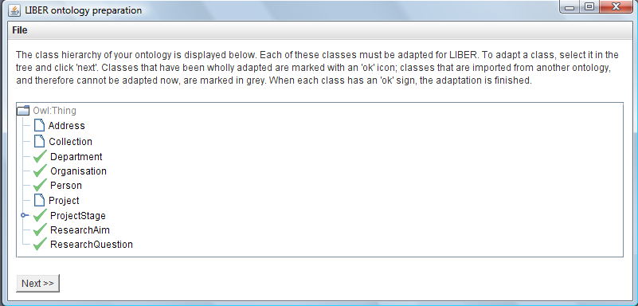
Figure 1: The Class Hierarchy Pane

Each class in the ontology is presented as a node. The grey nodes are classes that have been imported from another ontology (e.g. ‘Owl:Thing’). The nodes with an ok-sign are classes that in principle are ready to be presented in LIBER; the others need more linguistic information. This does not necessarily mean that the adaptation is finished to your satisfaction; it merely means that LIBER will not crash when encountering an instance of this particular class. It may not generate a meaningful description! The Adaptation process may be completed when each class has an ok-sign, but you will have to check each class yourself to see if its instances would appear in LIBER to your satisfaction.
To adapt a class, select it in the tree and double-click, or press ‘next’.

3. The Class Adaptation Pane

You will then see a pane in which you can add information about this class and its properties (see figure 2). On the left side, you see an abstract representation of the LIBER pop-up menu associated with this class. If the user clicks on an instance of this class, this is the menu that will appear. On the right-hand side are listed all other properties of this ontology, that have not (yet) been included in the interface. You can drag properties between the menu-tree and the list to add or remove them from the LIBER interface.

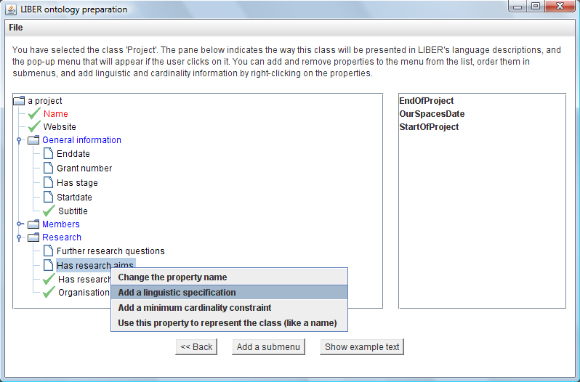
Figure 2: The Class Adaptation Pane

The menu-tree is divided into submenus (the blue nodes). To add a submenu, press ‘add a submenu’ and enter its name. You can then drag properties into it.
The properties with an ok-sign have sufficient linguistic information attached to them, the others need more. The red nodes are nodes that have a minimum cardinality constraint greater than zero. They must appear in the interface, otherwise users would create metadata not in accordance with the ontology! To add further minimum cardinality constraints, right-click on the correct property, select ‘add a minimum cardinality constraint’ and enter the minimum.
The name of each node is its natural language representation, which by default is derived from the local resource name. To change this representation, right-click and select ‘change the property/class name’.

3.1 Using a property to represent a class
Each class may have one or more properties which are used to represent it, from which proper names are derived. For example, the class Person has two such properties: Name and Gender. When we refer to a person, we call him or her ‘John’ or ‘Mary’, not ‘some person’. We can also use a pronoun, where the choice between him, her and it is determined by gender. To state that the value of a certain property should be used to represent the class, rather than a generic description based on the class name (i.e. ‘Mary’ rather than ‘some person’), right-click and select ‘use this property to represent the class’. This property will then not be represented explicitly, as a complete sentence (LIBER will not generate ‘some person’s name is Mary’), but implicitly, using it to describe the class instance (‘Mary is a member of PolicyGrid’).

For all other properties in the menu-tree, you will need to create a linguistic specification. To do this, right-click and select ‘add/edit linguistic specification’; the process is described in section 4.
When every property in the menu-tree has an ok-sign, the class has been adapted for LIBER completely. This explains why initially an ontology may look almost finished; if no properties have been dragged to the menu, no linguistic information is necessary, but no description can be generated either!
If you want to see what a description of the class might look like with the current information, press ‘show example text’. A window will appear with an example of a LIBER description of an instance of the class, complete with pop-up menus. Click ‘back’ to return to the class hierarchy pane.

4. Creating a Linguistic Specification

To create a linguistic specification for a property, right-click and select ‘add/edit linguistic specification.’

4.1 Specifying information for the template generation
Before the tool can generate suitable templates for your specification, it may need you to supply some information. You will first be asked for the root of the most important word in the sentence. This sounds complicated, but it simply wants the most characteristic word of the sentence that will present the property.
For instance, imagine you are creating a specification for the property ‘HasAuthor’, and are thinking of a sentence like ‘John is the author of some paper’. ‘John’ and ‘some paper’ are representing the source and target of the property, and can be ignored; the most characteristic word that remains is ‘author’. The root of the word simply means the word as it would appear in a dictionary; not pluralised, and in the case of a verb the infinitive (i.e. ‘be’ rather than ‘am’). The root of author is therefore simply author.
As a second example take the property ‘references’, presented in natural language as ‘some paper references some other paper’. The most characteristic (in fact, the only) word in the sentence is ‘references’. The root (infinitive) of that is ‘reference’.

Once you have supplied the root word, you may be asked to provide a suitable target value for a property if that property is a datatype property. For instance, with the property ‘HasEmail’ the tool needs a suitable example (j.smith@fiction.com) to generate a convincing surface form (Some person’s email address is j.smith@fiction.com). Please enter a value that might occur in genuine metadata.

4.2 Selecting a template
Once this information has been entered, the tool will generate a number of templates, potential surface forms that include your root word and example, and present them in a list on the left side (see figure 3). Some templates may look suitable, and some will certainly look ridiculous. Select the most promising template by double-clicking on it. You can then refine this template until you are satisfied with it.
Sometimes all templates will look strange. Please remember that you can change quite a lot when you refine your template, e.g. switching the source and target can make quite a difference! If you are truly dissatisfied with all templates, you can always click ‘cancel’ and try using a different root form.

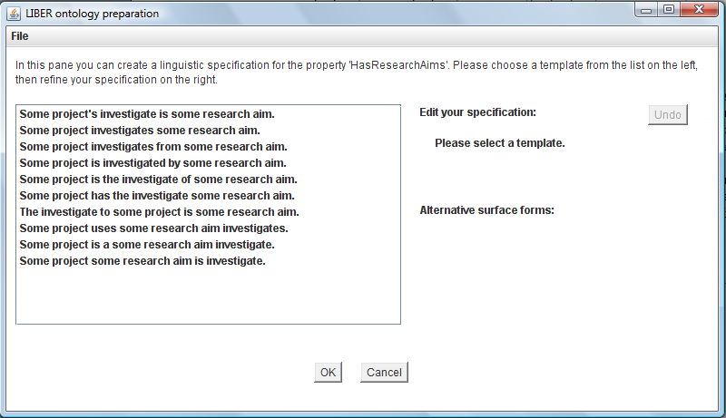
Figure 3: The template list.

4.3 Refining the surface form
When you select a template, it appears on the right side as a specification that can be manipulated (see figure 4). Below this specification all surface forms that could be generated from the specification are generated. Please check these carefully for linguistic errors before you submit your specification!

Each blue phrase can be changed in various ways. Right-click to show the pop-up menu with the options. The following explanation assumes you are familiar with the terms ‘noun’, ‘verb’ etc; if not, please read the appendix first.
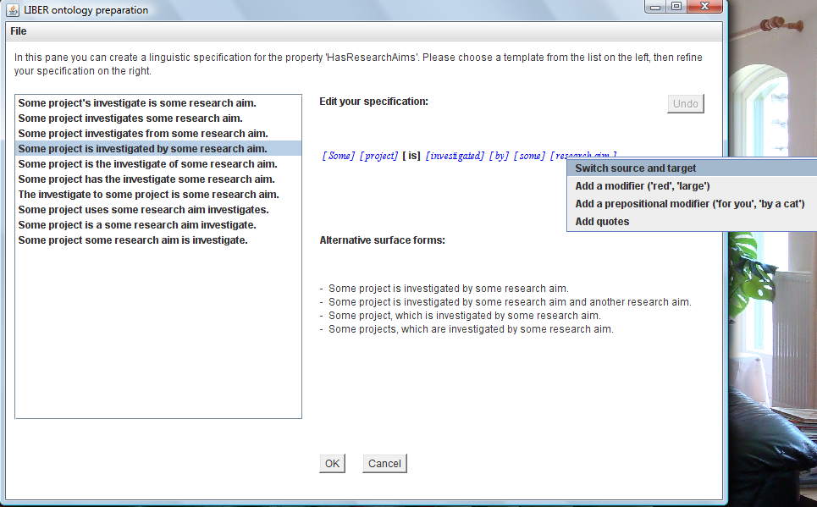
Figure 4: Refining the template

Switching source and target: The source and target of the property can be switched; in the example in figure 4 this would generate ‘some research aim is investigated by some project’, a marked improvement.

Changing a word: Many words can be changed. For instance, ‘investigated’ could be changed to ‘researched’. However, always remember to enter the root form (‘research’).

Adding a modifier: Noun phrases (e.g. ‘some person’, ‘the red car’, ‘John’) can include adjectives. Adjectives are words such such as ‘red’, ‘large’, ‘clever’ – basically, words that describe some feature of the object denoted by the noun. If a noun phrase does not already have an adjective, you can add one.

Adding a determiner: Many noun phrases include determiners, words like ‘the’, ‘a’, ‘some’, ‘this’, etc. If a noun phrase does not have a determiner yet, you can add one.

Adding a prepositional modifier: Noun phrases (e.g. ‘some person’) can also include prepositional modifiers, phrases such as ‘of Canterbury’, ‘in Aberdeen’, ‘from the University of Aberdeen’, etc. These phrases always start with a preposition (of, for, in, on, by, etc) and add some information about the noun. If a noun phrase does not already have a prepositional phrase, you can add one.

Adding an adverb: Verbs can have adverbs, words that specify some property of the verb, for instance ‘diligently’, ‘intelligently’, ‘slowly’, etc. If the verb has no adverb yet, you can add one.

Adding a modifier at the beginning of the sentence: Certain words specify a property relevant to the sentence that in English has to be stated at the beginning or end of the sentence (e.g. ‘yesterday’). LIBER will always put such words at the beginning of the sentence.

Removing a word: Determiners, adjectives and adverbs can be removed as well as added. To remove a prepositional modifier, you have to click ‘undo’!

Setting a word to plural: You can set individual nouns and verbs to plural, e.g. changing ‘research’ to ‘researchers’. It is very important to pluralise words this way, rather than entering the plural form as the root! When generating alternative surface forms, LIBER can set certain words to plural. For instance, when stating that a paper has three authors using the specification ‘some person is an author of some paper’, the surface form would be ‘John, Mary and Bill are authors of some paper’. If LIBER treated a pluralised word as a root form and e.g. tried to set ‘authors’ to plural, the result would be ‘authorses’!

Changing the verb tense: You can change the verb tense to past, present and future (investigated, investigates, will investigate).

Adding quotes: If necessary, you can add quotes around a phrase (e.g. around a title). You can also remove quotes.

With these options a template can be changed until it represents the meaning of the property well. For instance, I have taken the template in figure 4 and executed the following steps:

- Switched source and target.
- Set the verb tense to ‘past’.
- Added the adverb ‘thoroughly’.
- Changed the word ‘by’ to ‘in’.

This resulted in the specification in figure 5. Note that the alternative surface are all valid, because I made only valid changes!
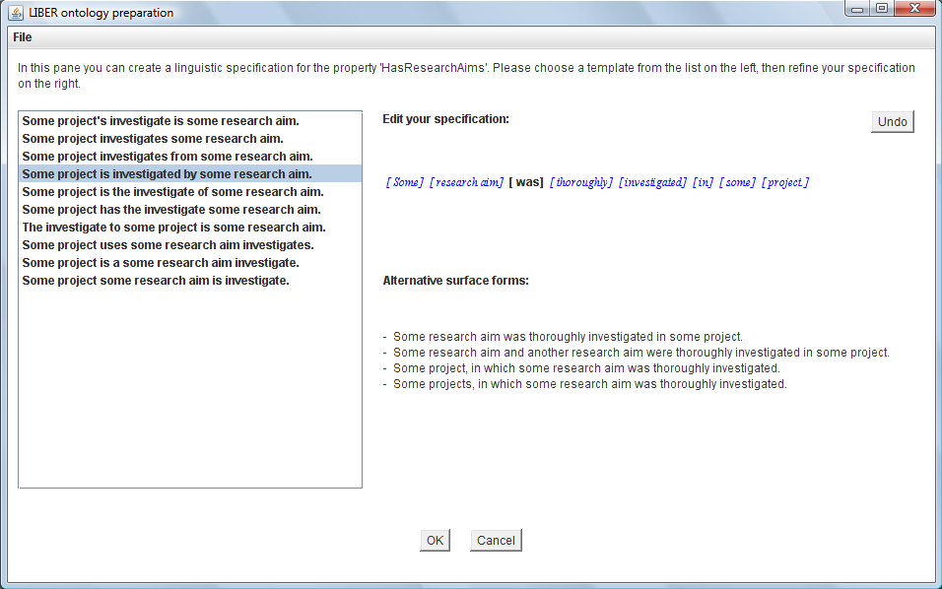
Figure 5: The final surface form.
4.4 Storing your linguistic specification.
When you are satisfied with the surface forms, click ‘ok’ to store your specification. If the property has an inverse property which does not have a specification yet, the tool will ask you if you wish to use the same specification. It will show you all possible surface forms that would be used to represent the inverse property (see figure 6). Although these may well look very similar to those of the original property, check them carefully! If you are satisfied with them, click ‘yes’ and your specification will be stored for both properties, and you will return to the class adaptation pane; if not, click ‘no’ to store the specification for this property and proceed to create the separate specification of the inverse property. Click ‘cancel’ to return to your specification.

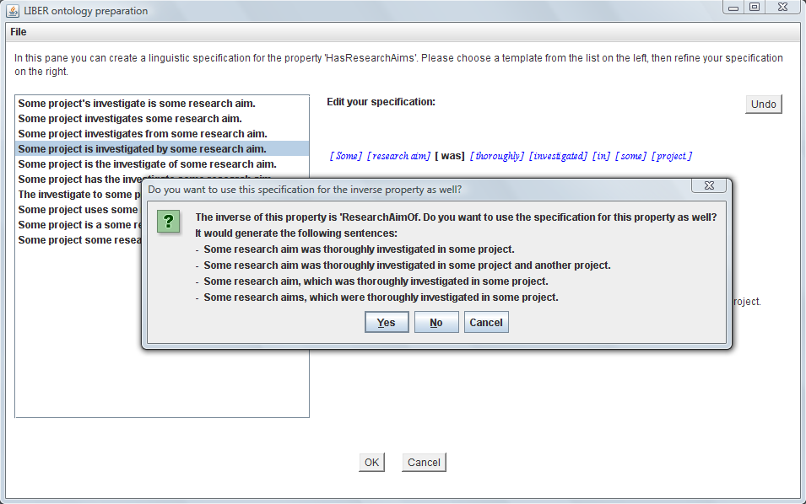
Figure 6: Using the specification for the inverse property.

6. Importing your ontology in LIBER
Once you have adapted your ontology, the following steps will export it to LIBER:
- Copy all xml files to the lexicon folder in tomcat;
- Copy the rdf file with your ontology, and any ontologies it imports, to the ontology folder in tomcat;
- Open LIBER’s OntologyReader class, and change the default constructor so it reads your ontology files, then recompile the package and copy the jar to the LIBER web application.
- If you intend to use the editing tool, open the file ‘ResourceTypeElicitor’ in that package. Replace every line ‘String[] text = {“Resource”}’, which specifies that users can only deposit objects of type ‘resource’, with lines that specify classes of your own ontology. Then recompile this interface using Google web toolkit.
- Restart the tomcat server.

You are then ready to start!

